H2Oil – Project

Blueprint Mockups

Index

**Logo** **2**

**Main Page** **2**

**Companies’ News Page** **3**

**Oil Spills Map** **3**

**Posts Page** **4**

**Profiles Page** **4**

# Logo



Our Website’s logo.

# Main Page

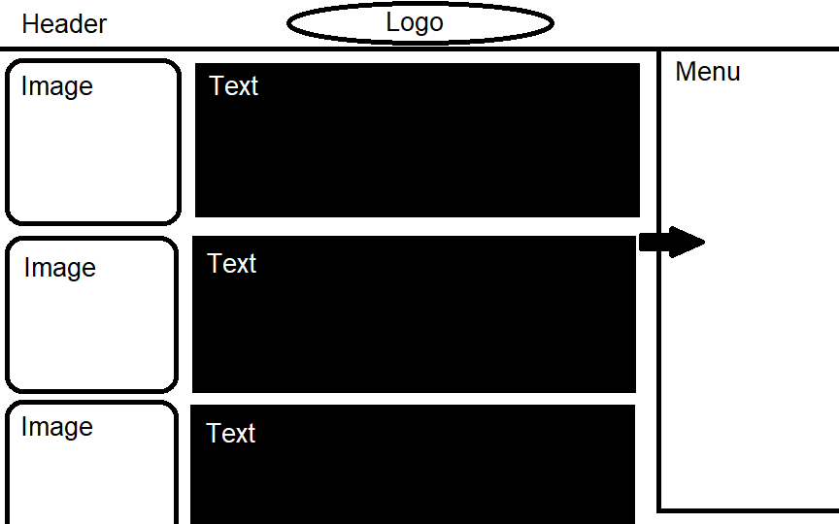

The Main Page of our Website. It displays relevant news and posts with their images attached. On the right side, a retractable Menu exists to allow the users to move to the other pages of our Website.

# Companies’ News Page

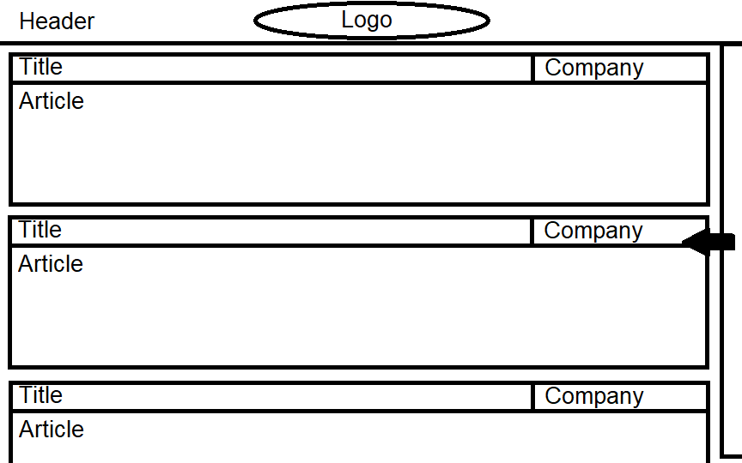

This page allows Companies to share relevant content about what they are doing in order to reduce/stop Oil Spills from happening again.

# Oil Spills Map

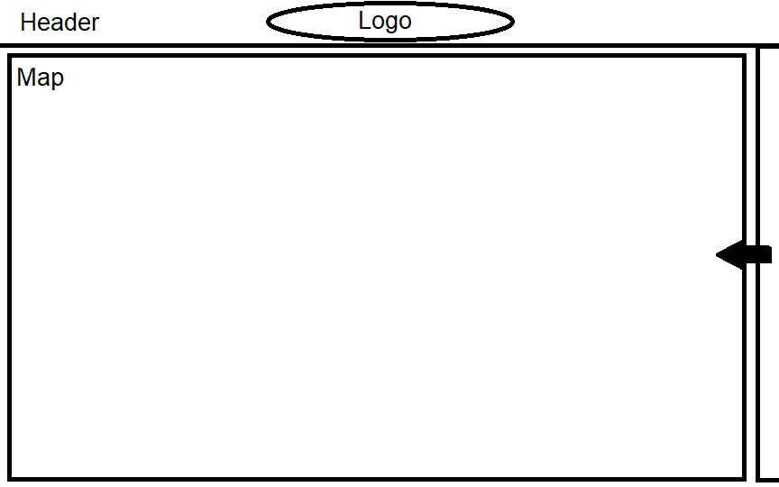

This page utilizes a map to inform the user of the location and other information about current and past Oil Spills.

# Posts Page

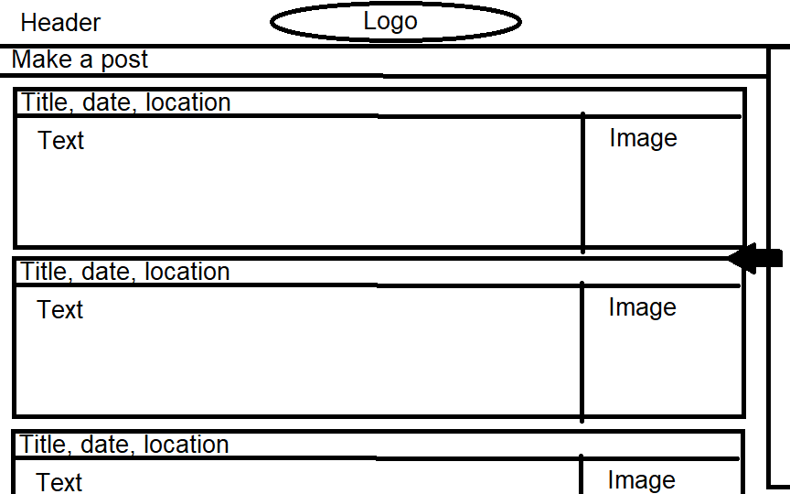

Here, users are able to create posts to share their experiences in the past with Oil Spills. Media can be attached. A report can also be done here based on suspicious sighting.

# Profiles Page

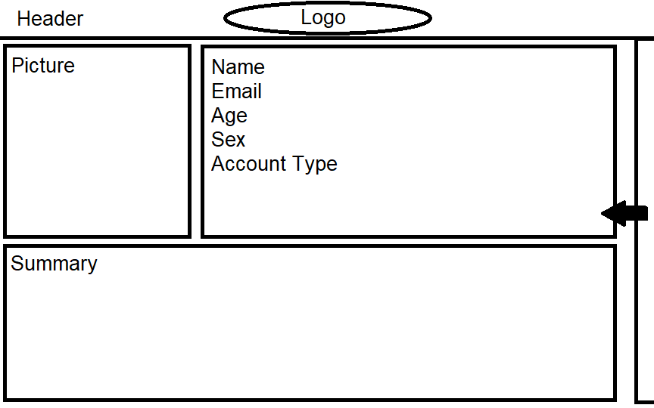

Profile pages will also be available. Users can set up a profile page with basic information about themselves for others to check.